# **User Guidelines for Covid-19 Analytics Report**

1. Users can visit the site to view the analytics report of Covid-19 using the <https://adityashah595728501.files.wordpress.com/2021/06/analyticsreport-1.pdf> link.



Figure . Analytics report URL

1. After clicking on the link or visiting the site user is represented with a Covid-19 analytics report.

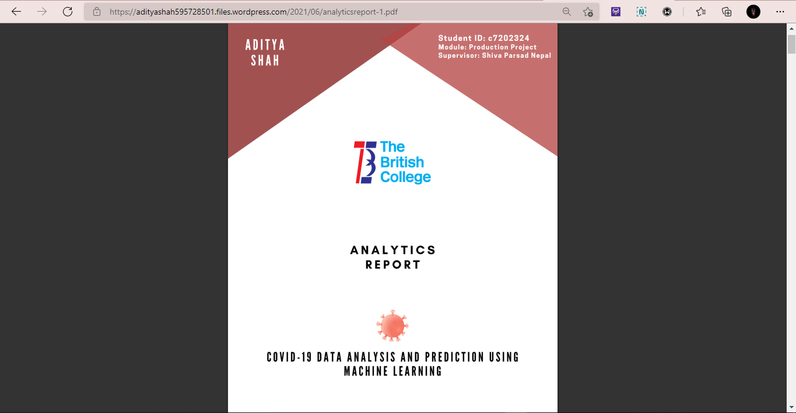

Figure . Firsrt page of report

1. Users can navigate through the table of contents and search for the desired topic to get information from.

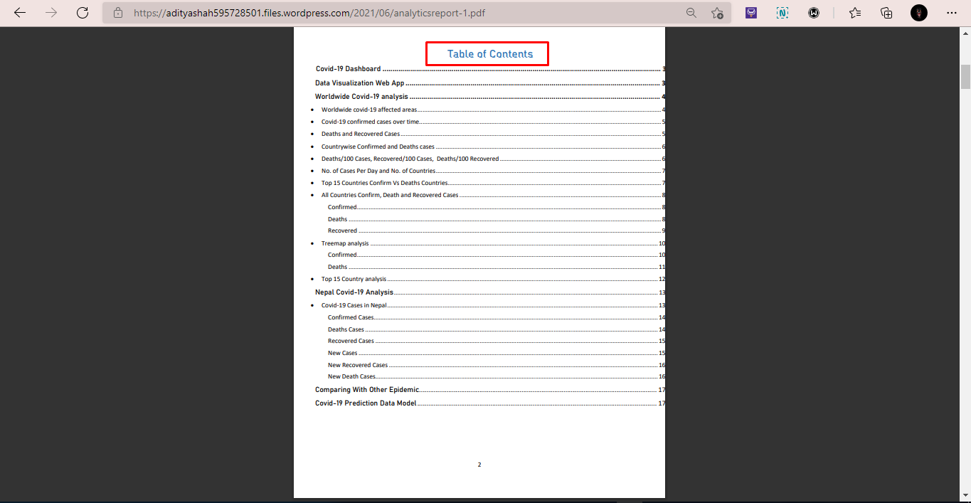

Figure . Table of contents

1. Users can download the Covid-19 analytics report from the save menu icon marked in the image.

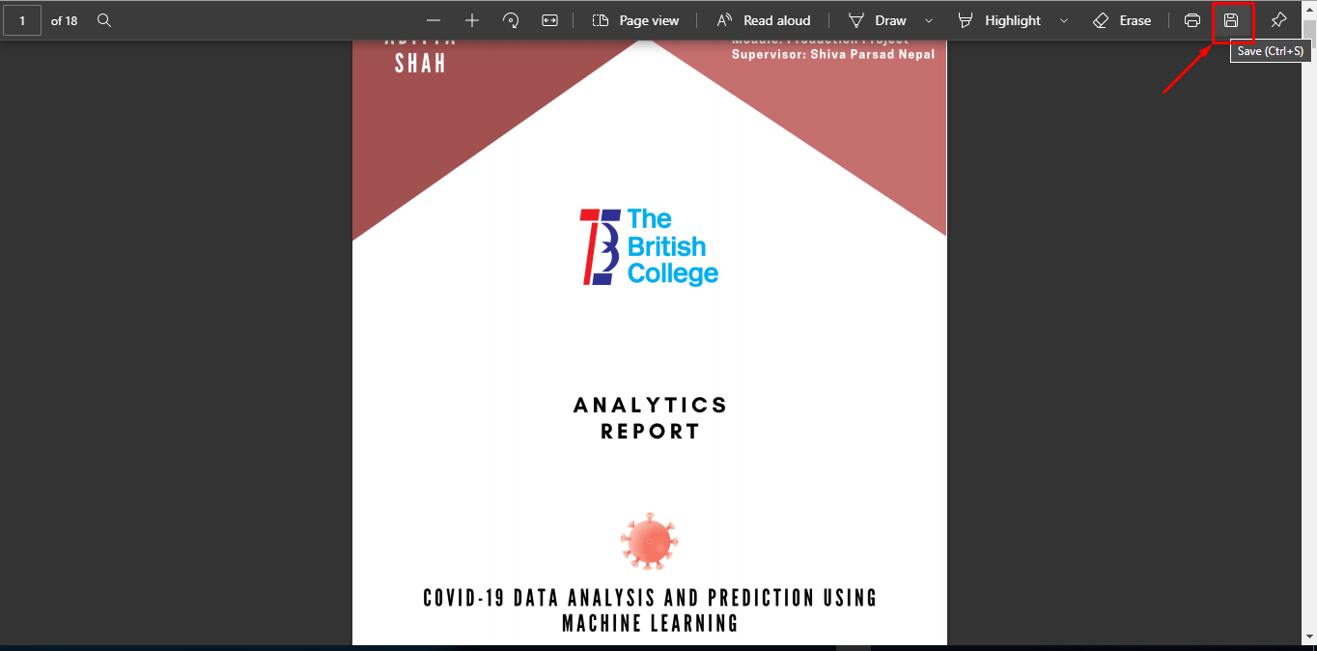

Figure . Save icon

1. Users can also print out the report of the Covid-19 analytics report to make hard copies by clicking on the print icon as shown in the figure.

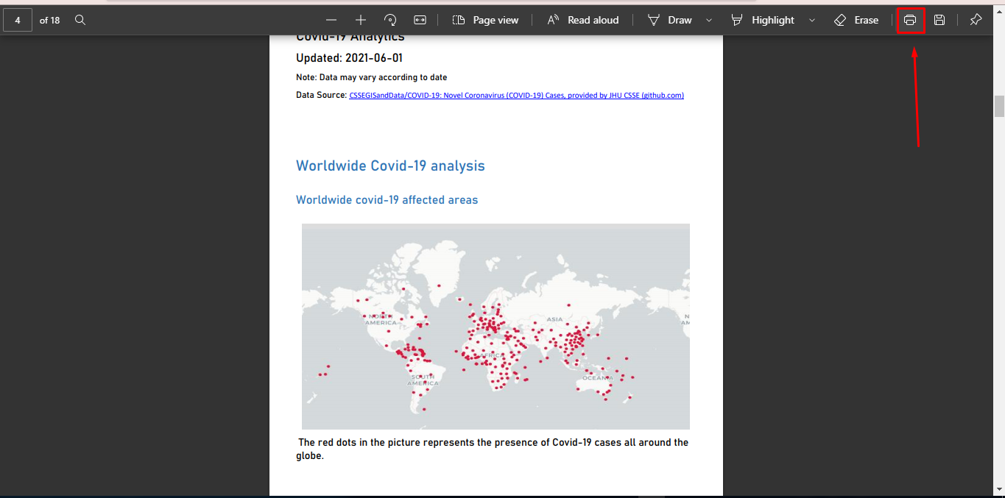

Figure . Print icon

1. Users can visit the Covid-19 dashboard and data visualization web app by clicking on the image or click as shown below.

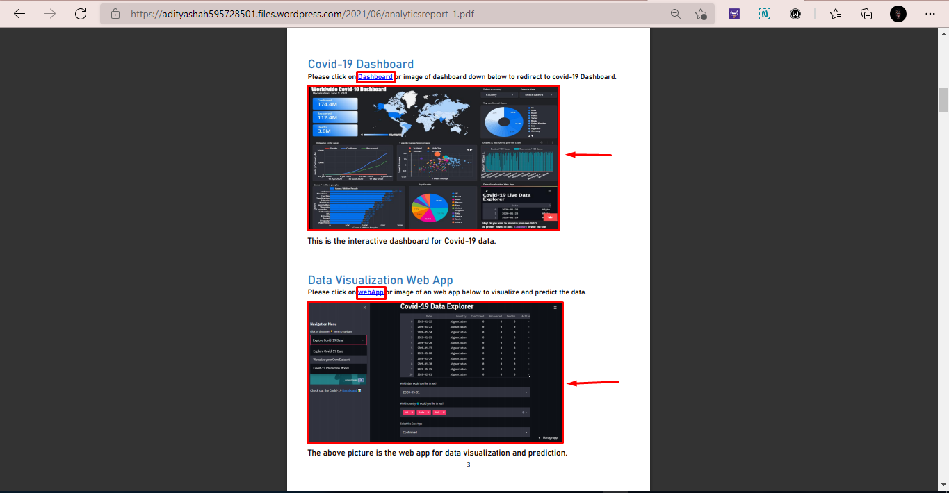

Figure . Links

1. To get information regarding Covid-19 cases of Nepal users can go to the table of contents and click ‘Ctrl+click’ on Covid-19 Cases in Nepal.

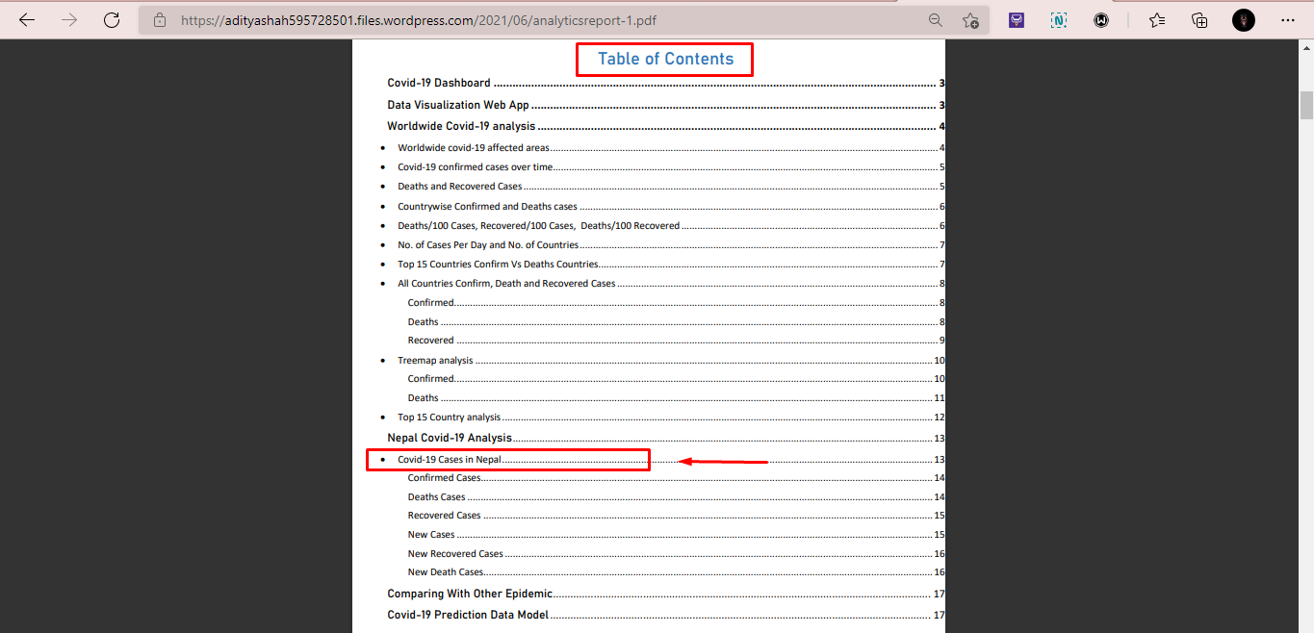

After clicking the user will be redirected to the Nepal Covid-19 section of the analytics report.

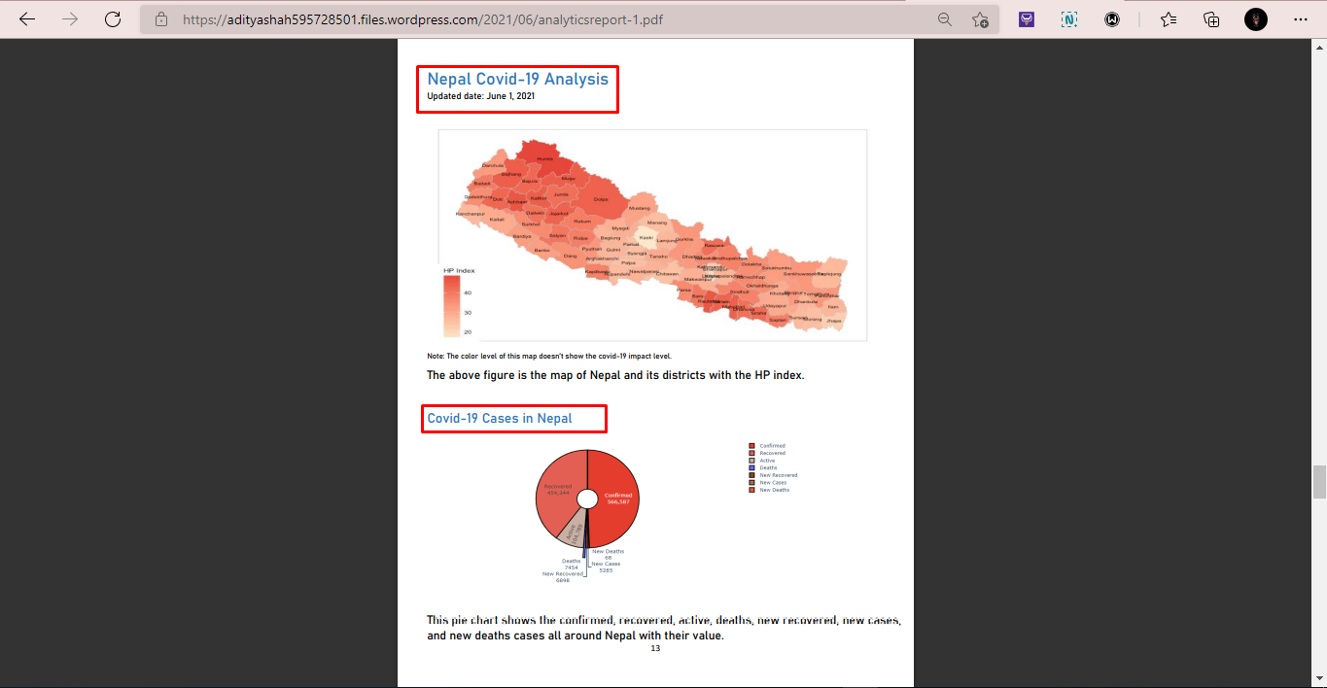

Figure . Nepal Covid-19 cases

1. Similarly, users can navigate the table of contents and visit the data source from where it was taken to perform data analysis and visualization.

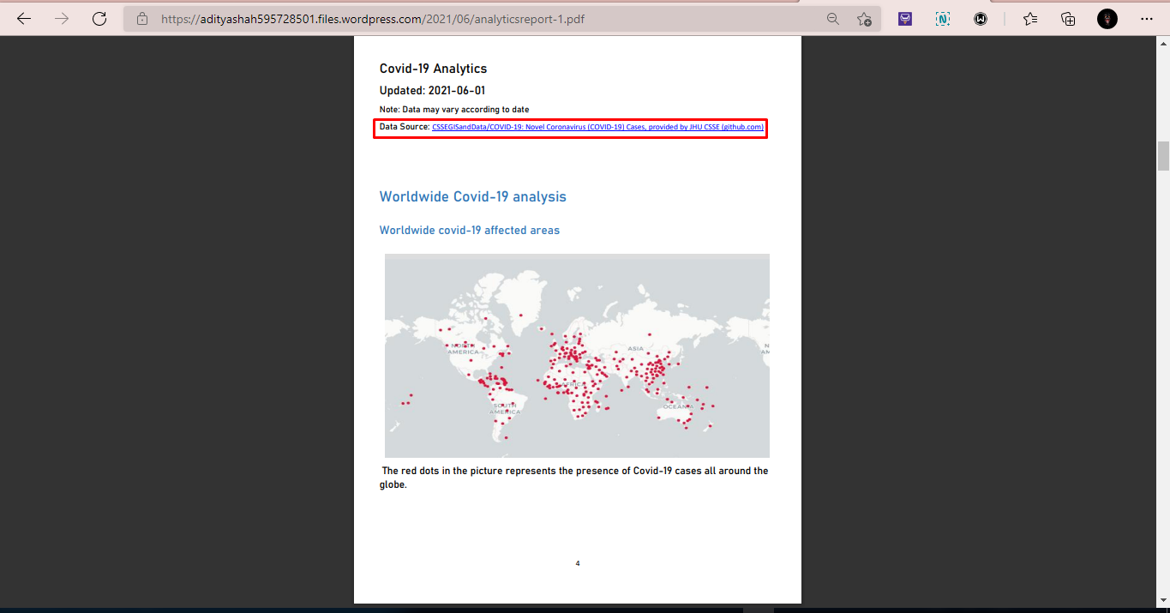

Figure . Data source

1. Users can see the chart and visualize information from any topics mentioned in the table contents of the report.

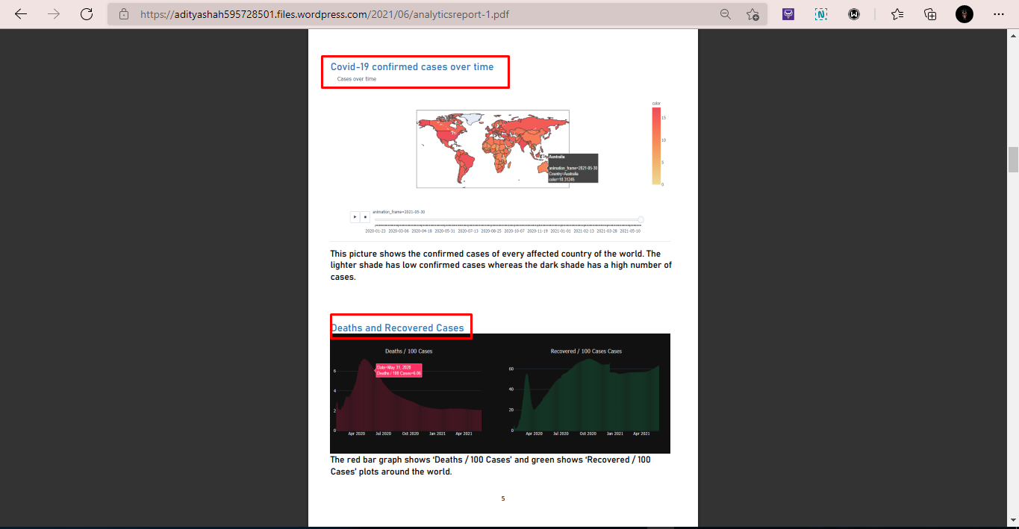

Figure . Covid-19 cases